TOUR AND TRAVEL MANAGEMENT.

TEAM MEMBERS:-

* SUBHADEEP MAJI
* SAYAN CHAKROBORTY
* SHREYOSHI MISHRA
* SNIGDHA CHAKROBORTY
* BIKRAMADITYA GHOSH

**ACKNOWLEDGMENT:**

I would like to express my profound gratitude to Mr. AYAN ROY MUKHERJEE for their contributions to the completion of our project titled TRAVEL BEA under the topic TOUR AND TRAVEL MANAGEMENT.

I would like to express my special thanks for his time and efforts he provided throughout the course. Your useful advice and suggestions were really helpful for us during the project’s completion. In this aspect, WE are eternally grateful to you.

Finally, I would like to take this opportunity to express my gratitude to all of my group members SUBHADEEP MAJI, BIKRAMADITYA GHOSH, SNIGDHA CHAKROBORTY, and SAYAN CHAKROBORTY,SHREYOSHI MISHRA. We would not have been able to complete this project without their help and cooperation.

SHREYOSHI MISHRA

**CONTENTS:-**

|  |  |
| --- | --- |
| **Subjects.** | **Page No.** |
| 1. Synopsis | 4 |
| 2. Technology | 5 |
| 3. Feasibility Study | 8 |
| 4. Characteristics of the Proposed System | 9 |
| 5. Data Tables | 10 |
| 6. Data Flow Diagrams | 11 |
| 7. Coding Part | 12 |
| 8. Screen Shots Of Form | 25 |
| 10.Future Scope | 30 |
| 11. References | 30 |

**SYNOPSIS**

**PROJECT MOTIVATION:** The main aim of the project was to develop a website which would facilitate the travel management for tours through an effective and yet simple GUI for any user. The user can sign up to our site and view plans book packages.

**INTENDED AUDIENCE**

1. The project is basically targeting those people who would like to travel with planned arrangements.
2. As we will be making our site HTTP – enabled, this will facilitate our site to accept requests from other alternative devices like PDA’s and HTTP-enabled browsers. Apart from the above category of audience, passengers using hand-held devices will be our second major category of audience.

**TECHNOLOGY USED:-**

**A. Server Technologies:**

***WEB SERVER: Tomcat Server***

***DATABASE SERVER: MS Access***

**B. Software Technologies:**

1. ***Java Server Pages (JSP)***
2. ***Java Servlets***
3. ***HTML***
4. ***JDBC***

***BRIEF:-***

**Tomcat Server:**

* + Tomcat is enterprise class, robust web server which comes bundled with Java Servlets and JSP that provides a java application server environment
  + One of the other major issues why we chose Tomcat was Scalability. Presently Java is our core technology used for portability and in future if we want to make our site be reachable to users using Microsoft products we would be having no conflicts between the servers because Tomcat can be deployed as either a standalone product with its own internal Web server or in conjunction with several other Web servers, including:

Netscape Enterprise Server.

Microsoft Internet Information Server.

Microsoft Personal Web Server.

* + It adheres to the latest standards, which expands the security features.  
    Configuration, tuning and maintenance are lot easier than compared to other prevailing web servers.
  + Since we were not going for enterprise java beans in our project we didn’t feel the necessity of going for other application servers like J2EE or JBOSS.

**MS Access:**

* Scalable
* Reliable
* Secure
* Indexed
* User Friendly

**Java Server Pages (JSP):**

* Regular HTML, of course, cannot contain dynamic information. JSP is so easy and convenient that it is quite feasible to augment HTML pages that only benefit marginally by the insertion of small amounts of dynamic data.
* JSP was designed to work with Java Servlets and JavaBeans in a seamless fashion; it provides applications developers with the capability to cleanly separate content generation from content presentation.
* This means that Web page designers can work independently from business logic developers, and the end result will work in a distributed, heterogeneous computing environment.

**Java Servlets:**

* Java Servlets are server-side technologies that provide a component-based, platform-independent method for building web-based applications. They provide web developers with a simple, consistent mechanism for extending the functionality of a web server and for accessing existing databases. Since our website was more database-centric we found Servlets as more appropriate choice.
* Servlets have access to the entire family of Java APIs, including the JDBC API to access databases. Servlets can also access a library of HTTP-specific calls and receive all the benefits of the mature Java language, including portability, performance, reusability, and crash protection.
* Our other alternative for Java Servlets was CGI. But we continued with Java Servlets mainly because of the following reasons:

1. Efficiency
2. Convenience
3. Power-pact

**Java Scripts:**

* JavaScript was basically used for client-side validation.
* JavaScript is compatible with all versions of Microsoft Internet Explorer and Netscape Navigator.
* We have small java scripts, which are lightweight and will not hinder the download time of the HTML document significantly.

**System Architecture:**

**Model - View – Controller:**

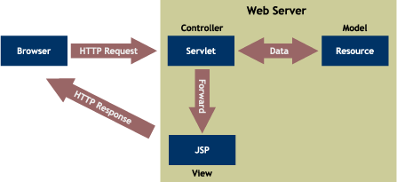

**Application’s Overall Architecture:-**

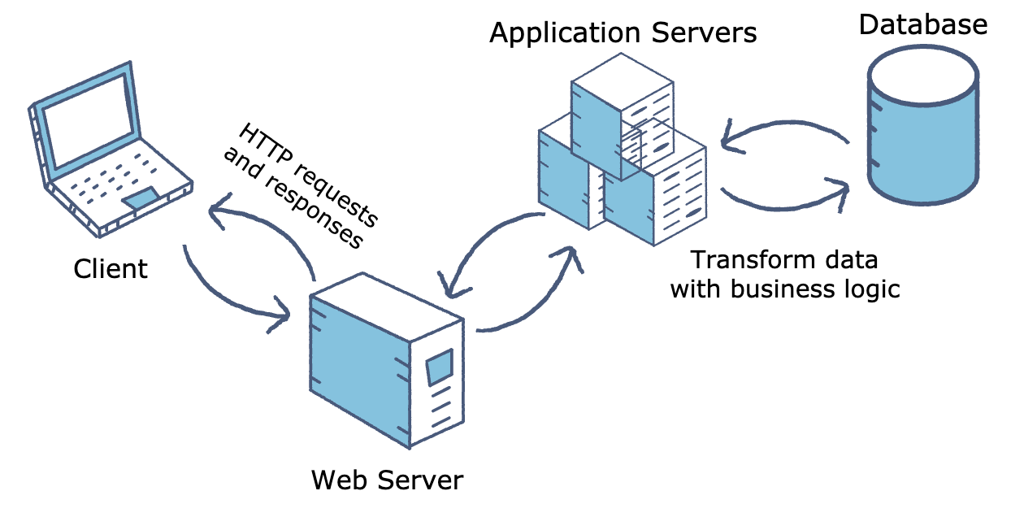

**FEASIBILITY STUDY**

**ECONOMIC FEASIBILITY:**

Economic analysis is most frequently used for evaluation of the effectiveness of the system. More commonly known as cost/benefit analysis the procedure is to determine the benefit and saving that is expected from a system and compare them with costs, decisions is made to design and implement the system.

This part of feasibility study gives the top management the economic justification for the new system .This is an important input to the management the management, because very often the top management does not like to get confounded by the various technicalities that bound to be associated with a project of this kind. A simple economic analysis that gives the actual comparison of costs and benefits is much more meaningful in such cases.

In the system, the organization is most satisfied by economic feasibility .Because, if the organization implements this system, it need not require any additional hardware resources as well as it will be saving lot of time.

**TECHNICAL FEASIBILITY:**

Technical feasibility centers on the existing manual system of the test management process and to what extent it can support the system .According to feasibility analysis procedure the technical feasibility of the system is analyzed and the technical requirements such as software facilities ,procedure, inputs are identified. It is also one of the important phases of the system development activities.

The system offers greater levels of user friendliness combined with greater processing speed. Therefore, the cost of maintenance can be reduced. Since, processing speed is very high and the work is reduced in the maintenance point of view management convince that the project is operationally feasible.

**CHARACTERESTIC OF PROPOSED SYSTEM**

**Current Manual System:**

The whole process of searching & booking the packages, was done manually till date. Processing the booking details by the agents used to take time when the software was not there into the picture.

**DISADVANTAGES OF Manual System:**

* It is very difficult to search for the best deal manually.
* The Manual system requires significant amount of human resources.
* The Manual system is more error prone.
* The Manual system is very time consuming.

**CHAREACTERSTIC OF THE PROPOSED SYSTEM:**

* The Online booking system is aiming to make the booking process faster, error free and cost effective for both Business and customers
* In comparison to the present system the proposed system will be less time consuming and is more efficient.
* Searching for the best deal will be very easy in proposed system as it is automated.
* Result will be very precise and accurate and will be declared in very short span of time because calculation and evaluations are done by the system itself.

**DATA TABLE USED**

**USER TABLE:-**

|  |  |  |
| --- | --- | --- |
| **NAME** | **TYPE** | **DESCRIPTION** |
| ID | TEXT | USER ID |
| NAME | TEXT | NAME OF THE USER |
| EMAIL | TEXT | EMAIL ADDRESS |
| PASSWORD | TEXT | PASSWORD |

**ADMIN TABLE:-**

|  |  |  |
| --- | --- | --- |
| **NAME** | **TYPE** | **DESCRIPTION** |
| ID | NUMBER | ADMIN ID |
| NAME | TEXT | ADMIN NAME |
| PASSWORD | TEXT | ADMIN PASSWORD |

**PACKAGE TABLE:-**

|  |  |  |
| --- | --- | --- |
| **NAME** | **TYPE** | **DESCRIPTION** |
| ID | NUMBER | AVAILABLE PACKAGES ID |
| DESTINATION | TEXT | PLANS |
| START DATE | TEXT | DATE OF JOURNEY |
| TOTAL DAYS | NUMBER | TOUR DAYS |
| TICKETS | NUMBER | TICKETS |

**ER DIAGRAM:-**

# USER MODULE:-

GUEST USER

REGISTERED USER

REGISTER

VIEW GALLERY

MANAGE BOOKINGS

VIEW PROFILE

LOGIN

# ADMIN MODULE :-

VIEW INFORMATION

BOOKINGS

FEEDBACK

USER DETAIL

GALLERY

PACKAGES

ADD INFORMATION

ADMIN DASHBOARD

OUR PAGES:-

HOME PAGE:- 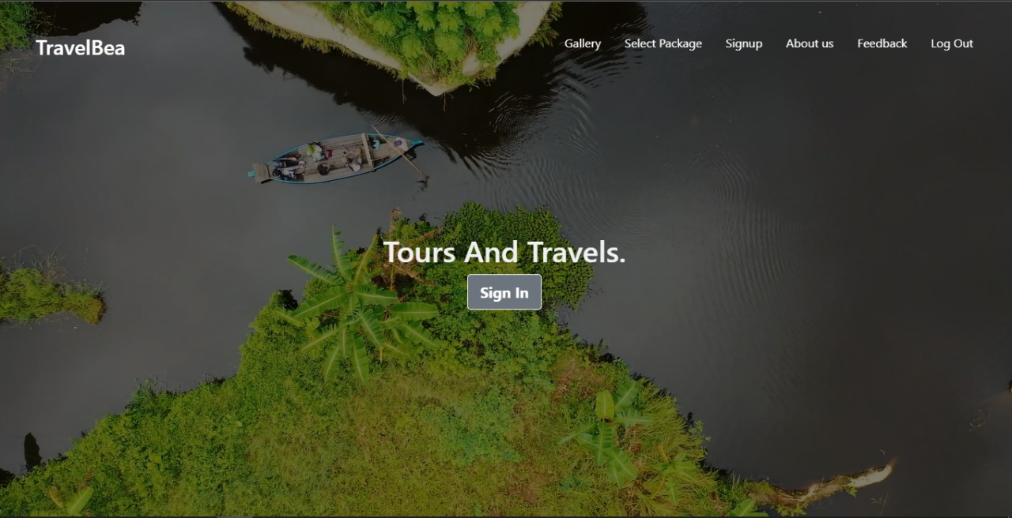

# SIGN UP & SIGN IN:-

|  |  |
| --- | --- |
| WhatsApp Image 2022-04-24 at 7.58.23 PM.jpeg | WhatsApp Image 2022-04-24 at 7.58.40 PM.jpeg |

# 

# VIEW PACKAGES:-

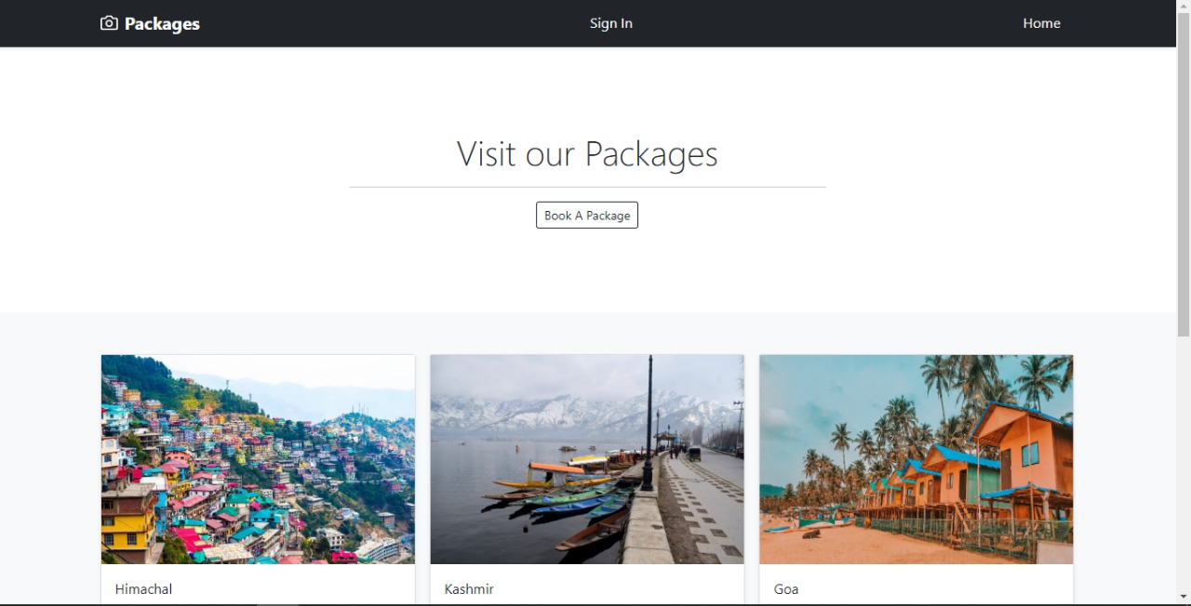

# BOOK PACKAGES:-

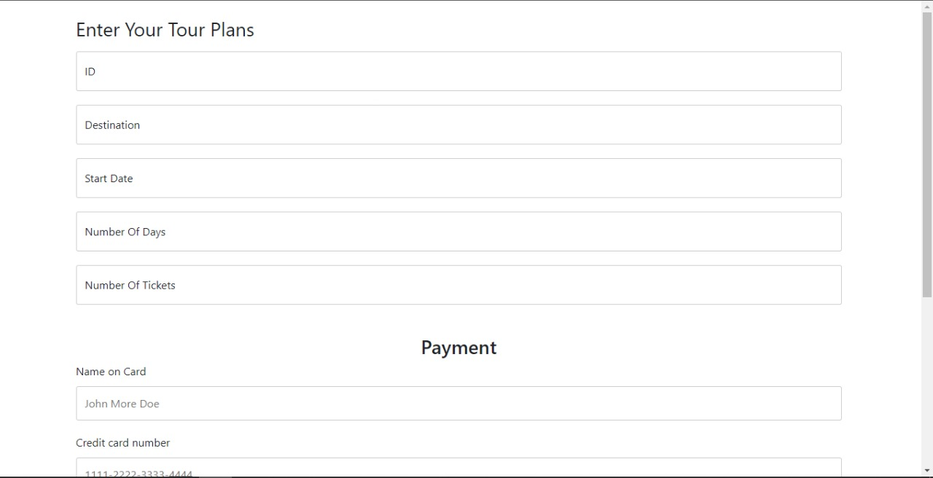

# GALLERY:-

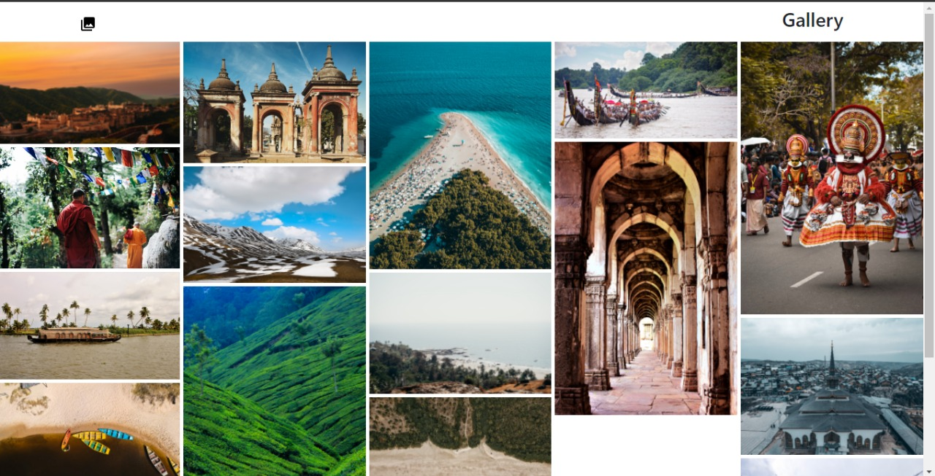

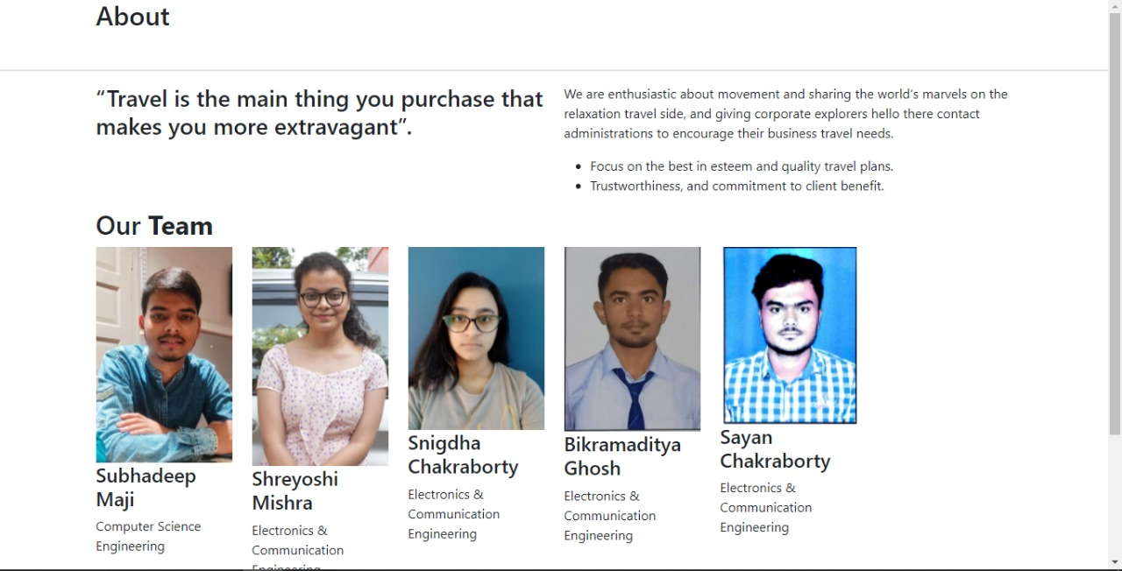

# FEEDBACK FORM

|  |  |
| --- | --- |
| WhatsApp Image 2022-04-24 at 8.00.49 PM.jpeg |  |

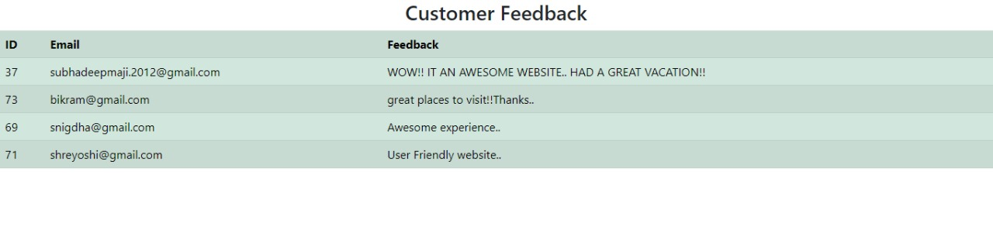

# BOOKING TABLE:-

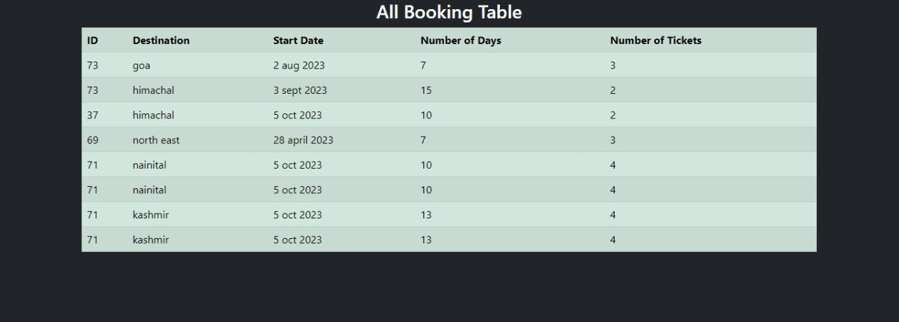

# PAYMENT:-

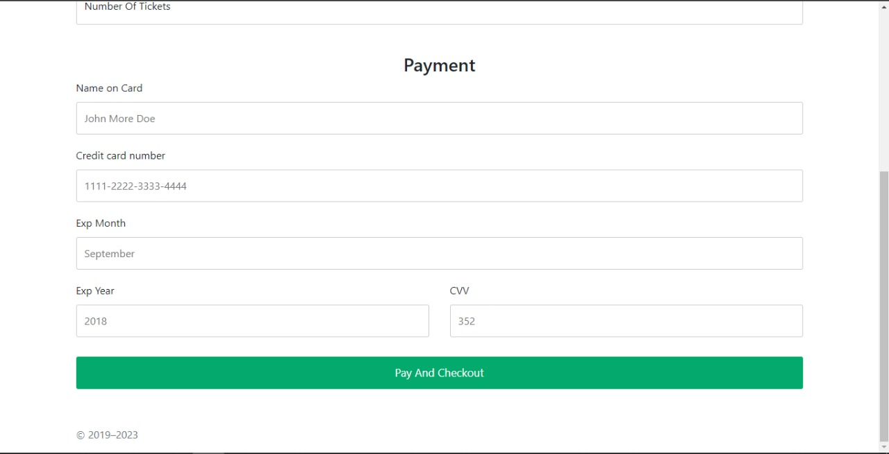

FUTURE ENHANCEMENT:-

* FLIGHT BOOKING
* HOTEL CHECKIN
* SITE VISITING

# CONCLUSION:-

Our project “travelbea” aims to provide an user friendly travel and tour management systems we have incorporated features like sign up for user, sign in, booking of packages, payment methods, customer feedback, and a gallery. We would sincerely work on for the accomplishments of the above mentioned future scope to make this a complete project.